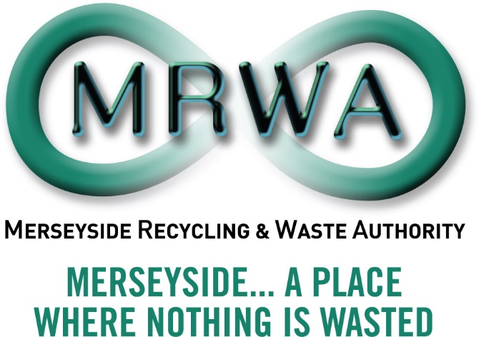

Circular Economy Teacher Education: Application Form
August 2024

Pack includes:
- Your Organisation
- Meeting the Project Objectives
- Finance
- Evaluation
- Conflict of Interest
- Other Issues
- Appendix 1: Timescales
- Appendix 2: Scoring Evaluation

Applications must be sent to danni.millar@merseysidewda.gov.uk by 5pm Sunday 8th September 2024. If you have any questions, please contact danni.millar@merseysidewda.gov.uk

Please ensure to read all of the associated documents entirely before completing this application.
Title of Project:
Date of Proposal:
 | 1.1 | Name of the organisation making this proposal. If you are working in partnership, please list all partners and indicate who will be the lead partner.
 | 1.2 | Contact name, and email address for enquiries about this proposal. If this is a partnership proposal, please list the lead contact.
 | 1.3 | If applicable, please provide your charity or company number below.
 |  | Company Number: |  | Charity Number:

- About your Organisation(s):

- Meeting the Project Objectives:
This section evaluates your skills and experience in relation to the specific project objectives.
  - Who would you engage with to begin making links with relevant educational institutions?

 | Please give the total number you expect to engage and then approximate numbers against each of the groups you propose to engage with.
 | Participant Type: |  |  |  | Number of Engagements:
 | Student Teachers
 | Teachers
 | Total:
 | Are there any groups you plan to engage with that are not listed?
 |  | Yes |  | No
 | If yes, who:

  - Zero Waste / Circular Economy knowledge and understanding.
Please tell us your experience/knowledge in the topics of Circular Economy and Zero Waste. (Max 500 words.)

  - Project Planning and Delivery
Please tell us about your experience in delivering educational/teacher training workshops, developing engaging resources, and planning and engaging with educational professionals.

Educational/Teacher Training workshops:
Developing resources:
Engaging with Education professionals:

  - Design of pilot project:
Please share your plans for how to deliver the MRWA Circular Economy Teacher Education Project 2024-25.

  - Implementation Plan and Timetable
 | Please describe each task you will undertake to deliver the project within time scales, ensure to show the key tasks involved in delivering the project, including when each task will happen, and demonstrating how the work will fit the planned start and finish date.
 | You will need to: | Approach and how will you record this?
 | Describe how will you engage with relevant education providers:
 | Describe how you will create content for workshops:
 | Describe where/how you conduct the project:
 | Describe how you will report anything extra outside the criteria that could be useful for added social value:

- Finance:
This section covers the financial request for the Circular Economy Teacher Education Project.
3.1 Your Organisation
Please indicate the amount which your organisation wishes to quote in order to deliver the project:
Total:
(Please remember we are supportive of paying Living Wage to any employees involved in delivering services as part of this contract.)
Please identify the three districts you plan to deliver the project in:

Halton
Knowsley
Liverpool
Sefton
St Helens
Wirral

3.2 Cost Breakdowns
 | Please provide a breakdown of these costs in the following table:
Eligible costs will include:
- Staff time: for activities associated with the project, such as meeting MRWA and other partners if required, understanding the engagement tasks, designing and carrying out the engagement, writing a report, presenting feedback and demographics of participants to MRWA, feeding back to community (if required) the way in which their input has been used by MRWA.
- Other costs: for activities associated with the engagement activity such as printing/photocopying, room hire, materials required to have an effective engagement, participant expenses/alternative, volunteer expenses and training, refreshments, childcare or other carer support costs, translation/production of information in alternative formats, appropriate support for participants in responding to issues arising in the engagement, film/photography, equipment etc.
- Contribution to management and overhead: for costs up to a maximum of 10% of the value of the overall cost.

 |  |  | Costs: | Hourly Rate: | No. of Hours: | Total Cost £:
 | 3.2a |  | Staff Time: please provide details for which staff would be involved for how much time:
 | 3.2b |  | Other Costs: please list costs associated with delivery and reporting
 | 3.2c |  | Management Overheads:  (Max 10%)
 |  |  | Total Costs:

- Evaluation
Please explain why your organisation is best placed to deliver this project: (Max 250 words)

- Conflict of Interest
5.1 Please indicate whether any known actual or potential conflicts of interest may arise in the provision of carrying out this engagement.

 | Potential Conflict: |  | No Conflict:
If there are actual or potential conflicts, please provide full details including:

- Brief description of the nature of connections creating actual or potential conflicts of interest.
- The full name of any people or bodies whose involvement gives rise to the actual or potential conflicts of interest.
- Mark with an (*) an organisation, people or bodies that are connected with MRWA.
- An explanation of how the Applicant proposes to deal with actual or potential conflicts so that they do not prejudice a fair and competitive procurement process or the position of MRWA.

5.2 Please indicate whether your organisation, or partners, have been recipients of MRWA and Veolia’s 2024-2025 Community Fund.

 | Yes |  | No
If your organisation, or partners, have been recipients of MRWA and Veolia’s 2024-25 Community Fund, please provide details including:

 | - Confirmation there is no overlap between this project and your community fund project
Please note if you have successfully been awarded any funding from MRWA and Veolia’s Community fund 2024-2025, you must show evidence there is no overlap of delivery with Circular Economy Teacher Education Project, including participants, targets, or engagements.

- Other Issues: Not for scoring.
Please use this space to highlight any other useful information for MRWA to consider in this project. (Max 150 words)

Please note the selected organisation will be expected to have all of the necessary accreditation/checks in place to undertake this project as described.

Appendix 1: Time Scales
Activity Detail: | Dates:
Project tender goes live | Thursday 22/08/24
Project tender closes | Sunday 5pm 08/09/24
Tender applications evaluated | 1 week evaluation
Organisation selected | w/c 16/09/2024
Due diligence | Following acceptance
Project initiation meeting | w/c 23/09/24
Final reports received | March 2025

Appendix 2: Scoring Table
Score: | Scoring Principles:
10 | Excellent – there is ample evidence to support the response.
8 | Good – there is sufficient evidence to support the response.
6 | Average – there is some evidence to support the response.
4 | Fair – there is little evidence to support the response.
2 | Poor – there is no evidence to support the response.
0 | Very poor – there is no evidence to support the response.

